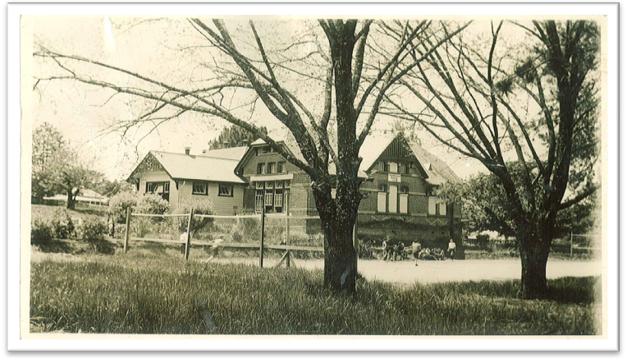


Information Book

2025/2026

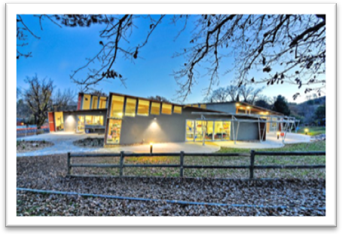

Every Child, Every Chance, Every Day

Contact Details

Yackandandah Primary School

39 High St
Yackandandah Vic 3749

Tel: (02) 6027 1431

Email: Yackandandah.ps@education.vic.gov.au

Michael.edwards@education.vic.gov.au

Website: www.yackaps@vic.edu.au

Principal - Michael Edwards
Business Manager - Sandra McKibbin
School Council President - Matt Flower

Staff – 2025
Foundation/One – Kelli Bedggood
One/Two –Hanna Kiely
One/Two – Ainsley Jones
Three/Four – Carly Frank
Three/Four – Angie Vincent
Three/Four – Robyn McLennan
Five/Six – Lauren Roberts
Five/Six – Brendan Hogan
Five/Six – Earle Mason
Inclusion & MHWL – Stacey Hogan
Art – Carolyn Martin-Doyle & Mandy Labram
LOTE – French – Mandy Labram
Music – Miriam Briggs
Physical Education – Robyn Wilson
Admin Assistant / OSHC Co-ordinator – Kerryn Wright
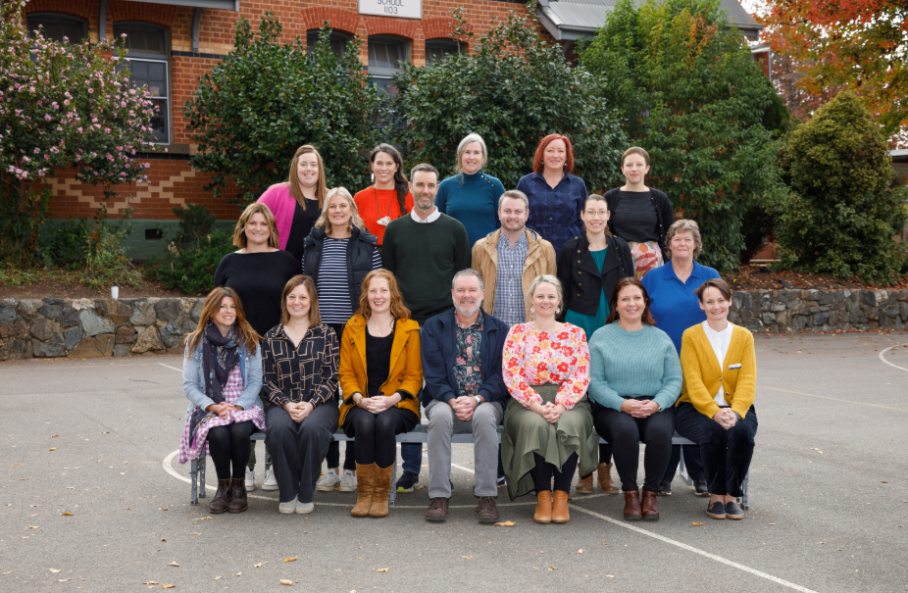

Staff 2024

Introduction
The information in this booklet is intended to provide parents, families and friends with a context and understanding of Yackandandah Primary School.
TERM DATES – 2025
Term 1: 28th January (Teachers start) to 4th April
Term 2: 22nd April to 4th July
Term 3: 21st July to 19th September
Term 4: 6th October to 19th December
Term Dates – 2026
Term 1: 27th January (Teachers start) to 2nd April
Term 2: 20th April to 26th June
Term 3: 13th July to 18th September
Term 4: 5th October to 18th December

The first day of Term 1 is a student-free day in all government schools to allow for appropriate planning to take place for the arrival of students. Each year government schools are provided with four student-free days for professional development, school planning and administration, curriculum development, and student assessment and reporting purposes. The remaining three student-free days are determined by each individual school.
SCHOOL HOURS

9.00 a.m. to 3.30 p.m.

Lunch 11.00am to 11.45am (supervised eating from 11.00-11.10)
Recess 1.45pm to 2.30pm

The learning of punctuality by students is important. They need to be at school by 8.55 a.m. when the first bell is rang in preparation for the 9.00 a.m. commencement of lessons.
In order to ensure safety, please do not send your child to school before 8.40 a.m. each morning. A teacher will be on duty between 8.40 a.m. and 9.00 a.m.

Students at school before 8.40am need to be booked into Before School Care which operates from 7am to 8.40am.

If your child is late to school he/she must be signed in via Compass.

NO STUDENT IS TO LEAVE THE SCHOOL GROUNDS AT ANY TIME
WITHOUT PERMISSION FROM A TEACHER
School Council

School Council meets monthly and has the role of making decisions regarding the direction and management of the school within DET guidelines. It consists of parents, principal and staff and School Council has the power to co-opt other community members. Currently school council consists of 8 parents and 3 Department of Education and Early Childhood employees.
All Parents are welcome to attend Council meetings.

Current School Councillors are:

- Matt Flower President
- Orrin Pritchard Vice President
- Brendan Hogan Secretary (DET)
- Michael Edwards Principal (Executive officer)
- Sophie Dewar Treasurer
- Chris Summons Vice President
- Kate Stagg Parent representative
- Andrew Davison Parent representative
- Janine Lerch Parent representative
- Sarah Crispin Parent representative

Powers and duties of the School Council include –
- Formulation of the School Strategic Plan
- Developing the education policy of the school, consistent with school goals and Department of Education guidelines
- Promoting parent and community participation and interest in the school
- Conducting educational activities for the benefit of the community
- Allowing use, by outside bodies, of the school building and grounds under its control
- Annual reporting to the school community
- Holding property on behalf of the Minister
- Purchasing equipment for the school
- Forming sub-committees
- Responsibility for the financial arrangements within the school
- Overseeing maintenance on buildings and grounds.
- Management of Outside School Hours Care.
- Management of Yackandandah Kindergarten.

School Council operates four sub committees (Finance, Grounds and maintenance, OSHC and Yackandandah Kindergarten Management Committee).

Our History – Yackandandah Primary School has been part of Education in the local area for 150 years – a history to be proud of:

1852 – First tent school in the gold fields

1855 – 1872 – The first school in Yackandandah is opened on July 1st, 1855 - A Church of England school (No. 694) that covered the primary years

1863 – First numbering of schools. Yackandandah School – Number 694

1864 – Sir Isaac Isaacs, number one pupil in the register at Yackandandah Common School

1872 – The new school opened on November 1st 1872, No. 1103. The previous school No. 694 was struck off the roll. The new building consisted of three rooms and the architect was James E Murphy.

1872 – Education act – Education to be secular, compulsory until the age of 15, free in basic subjects.

1873 – Education Department established and Yackandandah School became a State School. John Bezley was the first head teacher. District Inspector Craig reported that, ‘Yackandandah was the most respectable school in a large district’.

1874 – Another brick building was added at a cost of 522 pounds.

1888 – Negotiations between the Church of England and the Education Department terminated with the sale to the department of the adjoining acre and a half of land. The price was 400 pounds.

1891 – A second brick school house was built on a more central part of the now enlarged ground, and it stands today as the dominant feature of the school complex.

1899 – The timber school at Eurobin was transported to Yackandandah and re-erected for use as an infant room. The first brick building, built 27 years earlier, no longer matched the needs of the school and was sold for removal.

1913 – District Inspector Thomas reported the need for more accommodation in the infant school. The department allocated 2900 pounds for two new classrooms, a cloak room and for the renovating of the school to take 180 pupils the next year. While the work was in progress, the public hall across the road was used. The children were back in their school in May 1916.

1924 – The department bought a six-roomed weatherboard residence for the head teacher.

1939 – Electricity was taken to the school.

1942 – 1945 – The RAAF used the head teacher’s office as a control room for the air observation corps, who were based at Wangaratta.

1948 - The school committee installed a wireless system with three extension speakers.

1958 – A bicycle shed was constructed by the school committee as well as a new shelter shed to replace the old one.

1964 – A new room for seniors was added to the school.

1972 – Centenary Celebrations

1973 – Back Creek School Closed

1974 – Purchase of old house next to school grounds for future playground extensions
1976 – Construction of the rock wall by prisoners from Beechworth prison.

1977- Gas heaters and new drinking taps were installed

1979 – A new portable classroom was sited, again relieving the overcrowding of classrooms.

1981 – Upgrading of old building including a library at the front of the building, librarian’s office, store room, principal’s office, sick bay, staff room, staff toilets and shower. One classroom was retained in the old building with four relocatables positioned on the eastern side of the school. Two houses on the west end of the school were purchased to allow expansion of the playground.

1982 – An old portable classroom was removed to make way for a new large relocatable double classroom. The windows on the old building were glazed (previously had been bricked up).

1983 – Regionalisation was introduced and local communities became more responsible for schools. Another large double relocatables classroom was added and covered walk ways were constructed.

1988 – Construction of new toilets.

1994 – Wooragee Primary School developed as an annex of Yackandandah Primary. Japanese language introduced to the school. Permaculture area developed in the school grounds. CASES administration system introduced to the school.

1999 – School Council purchase of building – used as an additional classroom.

2000 – Use of ‘His Place’, a hall across the road as an art room.

2002 – Construction of a new permanent classroom. Indigo Shire Outside School Hours Care uses school facilities.

2003 - Construction of a new courtyard area. Development of a three year plan to upgrade computer resources throughout the school. Yackandandah Primary managing all aspects of After School Care.

2004 – A 20% growth in enrolment resulting in a portable classroom installed on the west end of the school. The commencement of the school organised Annual Billy Cart Race event.

2005 – 150th Celebrations including a bush dance and the planting of a time capsule. Multipurpose room facilities improved. CASES 21 pilot school. Development of the School Garden Club.

2006 – Installation of a new playground. Development of new School Motto.

2007 – Installation of new interactive whiteboards in each classroom, shade sails installed over play area and old building roof replaced. New School Logo introduced. Community Links Regional Award.

2008 –Building Futures process – Masterplan developed. New school website.

2009 – Netbooks in the 5/6B classroom as part of a pilot program. Building Futures process continues.

2010 – Construction of new school/removal of all portables. Refurbishment of old building.
2011 – New school complete and official opening.

2018 – Basketball Court resurfaced

2019 - A new portable classroom was sited, again relieving the overcrowding of classrooms.

2021 – Completion of Dry Creek Bed landscaping project.
Profile
Yackandandah Primary School is situated in North-East Victoria between Beechworth and Wodonga and some 300km from Melbourne. It serves a community within a 20km radius from which the students are bussed, driven, walk or ride to school. Yackandandah is a picturesque and historic town with a strong heritage linked to the early discovery of gold in 1852. The preservation of heritage buildings, a hub for artistic endeavours and a scenic setting have all promoted Yackandandah as a tourist destination.
The school has attractive surrounds which include an engaging playground and equipment, as well as passive play areas. The current student enrolment is 184 students. Yackandandah Primary operates nine class groups with an overall teaching staff of 12.2. The nine class groups operate in learning centres. The school is supported by an office manager. The school provides Visual Arts, Music and French programs. There is also a strong leadership program in place. Student voice is evident through Junior School Council.

Other Significant Factors
- The new school has several flexible and dedicated learning spaces. This includes a kitchen, conference room, library resource area, art/music room and several ‘wet’ areas. All the indoor learning centres lead to outdoor learning spaces such as the deck and top courtyard.

- A specialist Music and Visual Arts program is offered to all students as well as private, ukulele, piano and guitar lessons. The Arts program is well established and resourced. This program is a highlight of the school and is valued by the community. A specialist French language program is also in place.

- We recognise the large role technology will play in your child’s future and as such, it is integrated into the curriculum across all year levels. This includes using technology for learning, interacting and sharing. Each student in Years 3/4/5/6 has access to a personal netbook computer to help them with their learning. There are ample ICT devices available for use in each junior classroom.

- The school focuses on identification of students requiring extra assistance and implements individual learning plans. The school is becoming proficient at the identification, intervention and monitoring of ‘at risk’ students. Of course, intervention may be applied to those students who require extension learning. These students also have access to a differentiated program that recognises and enhances their learning.

- The students at Yackandandah Primary are fortunate to have the opportunity to participate in a number of extra activities which enhance the curriculum. These activities include – a snow skiing program, cultural activities, a camp program for Years 3-6, excursions for each year level each term to enhance the classroom foci, a swimming program from F-6, unicycling and more. The school has developed strong relationships with many local sports and recreation organisations.

  - Outside School Hours Care - The school operates before and after school care as well as a holiday program. The school manages all aspects of this program including staffing, funding, accreditation and accountability.
  - The school is also the nominated provider for the operation of the Yackandandah Kindergarten. The primary school council manages and is responsible for the operation of the kindergarten. The liaison between the two institutions strongly supports a focus on early childhood learning.

  - The school has outstanding support from parents and the wider community in areas such as fundraising, working bees, camps, reading, hot lunches, book club, assistance with the newsletter, and using community expertise to support learning.

• Community involvement – Yackandandah Primary School has a high commitment to community involvement and is an integral part of the broader community. The school participates in a number of community events throughout the year including the Folk Festival, Anzac Day and presenting on Indigo FM. The school also has many links with groups such as the RSL, sporting bodies, senior citizens and the Indigo Shire.

Vision, Values and Goals

VISION

Yackandandah Primary School has an expectation that children will be happy, confident, self-disciplined and motivated risk takers who strive for excellence whilst having respect for one’s self and others. The school seeks to engender a positive community spirit which encourages learning in a caring, family atmosphere where children are the focus and individual needs are met. We seek to provide a safe, happy and responsible school community in which your child can learn and be valued as an individual within the context of a wider community.

Our School affirms the democratic principles: elected Government; the rule of law; freedom of religion; freedom of speech and association; and the value of openness and tolerance.

VALUES
The values which form the basis of our actions are:
- We show Respect
- We are Fair
- We are Learners

STRATEGIC PLAN / ANNUAL IMPLEMENTATION PLANS:
In 2021 our school completed a comprehensive review of our previous strategic plan. A new four year strategic plan has been developed to take Yackandandah Primary School through to the end of 2025. The plan aims to boost our already strong achievements while maintaining our community based philosophy.

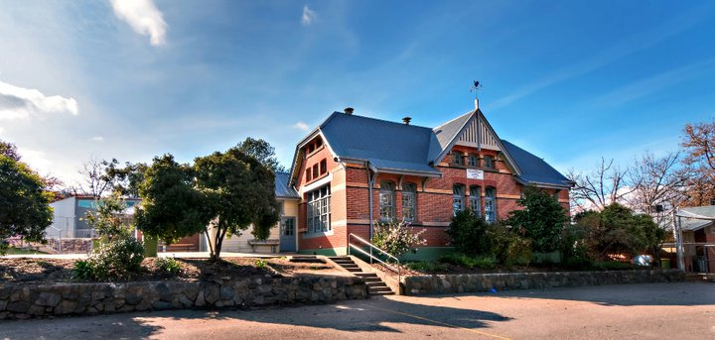

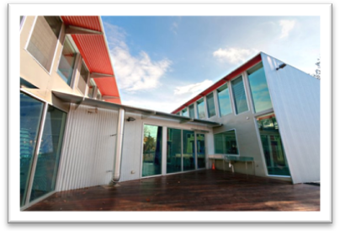

CURRICULUM

At Yackandandah Primary School we have high expectations that all our students will reach their full potential and excel to the best of their ability in all domains and facets of schooling.

The Victorian Curriculum is the Foundation to Year 10 curriculum that provides a single, coherent and comprehensive set of prescribed content and common achievement standards, which this school uses to plan student learning programs, assess student progress and report to parents.
Students need to develop a set of knowledge, skills and behaviours which will prepare them for success in their rapidly changing world.

All students need to develop capacities to:
  - manage themselves as individuals and in relation to others
  - understand the world in which they live
  - act effectively in the world

Cross Curriculum Priorities in the Victorian Curriculum
Victorian Curriculum must be both relevant to the lives of students and address the contemporary issues they face. With these considerations the curriculum gives special attention to these three priorities:
- Aboriginal and Torres Strait Islander histories and cultures
- Respectful Relationships
- Sustainability.
At Yackandandah PS we have a well-developed social and emotional learning program that emphasises personal strengths, resilience and tolerance.

SPECIAL PROGRAMS

Social and Emotional Learning - Social and Emotional Learning (SEL) is taught weekly. It involves working with students to explore how our school, community and national values are expressed in our words, actions and attitudes. The aim of SEL is to be proactive in building positive behaviours, resilience and respectful relationships. SEL helps give children the skills and knowledge to self-manage their learning, emotions, friendships and other interactions. SEL also builds a common language around how we interact and manage ourselves.

PADSIP – An intergenerational program involving residents at Yackandandah Health and Yackandandah Primary School senior students. Students develop relationships with residents over several meetings and create an audio visual presentation about them.

Unicycling - Yackandandah Primary introduced unicycling to Year 5 & 6 students in 2007. Unicycling was chosen for the many benefits for the rider. Along with building physical fitness and strength, unicycling enhances self-esteem and builds trust and cooperation between the rider and the teacher. Research has shown that unicycling improves academic performance, develops balance and gives students a unique skill that can be further developed.

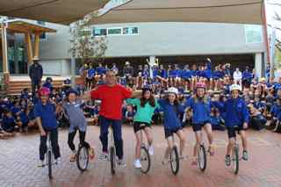
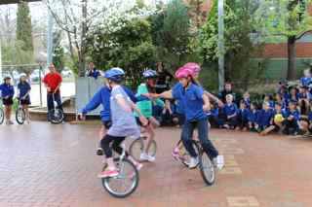

Waste Wise – Yackandandah Primary School is a Waste Wise School. A waste wise school is one that makes a commitment to and then meets state-wide standard criteria for excellence in minimising waste and litter. Each classroom at our school has a compost bucket, recycling box and a waste bin.

LOTE – At Yackandandah Primary School all students participate in the French Language Program.

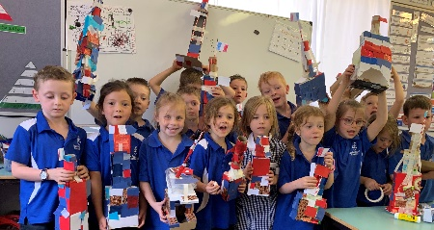

Arts - There is a strong emphasis on The Arts with the school providing specialist Music and Visual Arts Programs. Extensive information and communication technology is provided to enhance curriculum delivery.
Yackandandah Primary School has two choirs – Junior and Senior. Both choirs participate in the Albury Wodonga Eisteddfod and the Wodonga Arts Festival as well as singing at local events such as the Anzac Day Ceremony. All classes also participate in the Arts Festival.
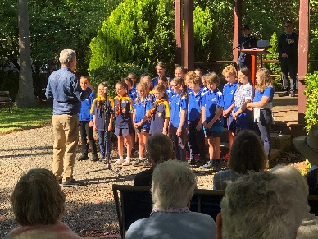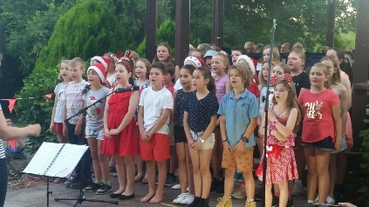
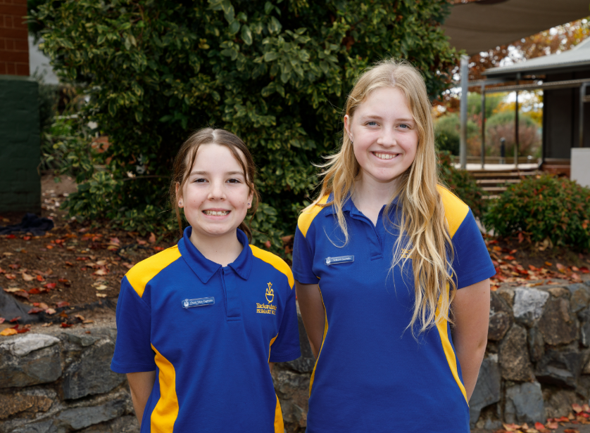
Choir singing on Anzac Day Choir singing at the Yack Carols 2024 Choir Captains

Excursions, Camps & School Activities – Each year we aim to offer all students excursions to enhance the units of work they are studying. Year 3 & 4 students participate in an annual 4-day camp and Year 5 & 6 students participate in an annual 4 day camp.
Excursions are arranged at reasonable intervals during the year to enable students to have first-hand contact with a variety of experiences. Care is taken to make sure that there are viable educational objectives in the excursion and that there are preparatory and follow-up lessons. Regard is given to the cost to parents and any family suffering financial hardship is invited to discuss the matter with the principal. Our policy is that no child should miss out if it can reasonably be avoided.

Parents can expect to be notified in writing well in advance of any proposed excursion. Written permission and authority to take emergency action in case of illness or accident is essential Working With Children Checks are required for parents attending overnight camps or long day excursions. 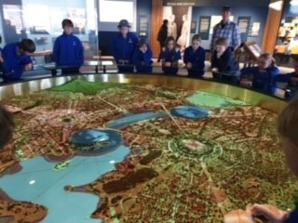 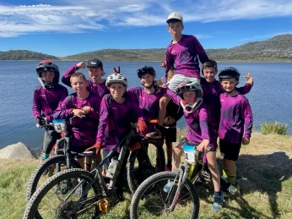 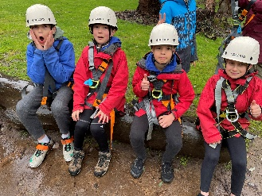

Yr. 5/6 Canberra Camp MTB Championships Yr. 3/4 15 Mile Creek Camp
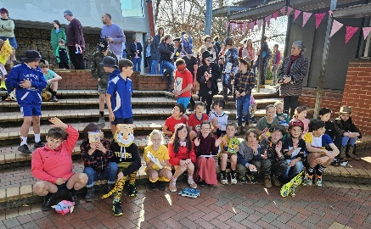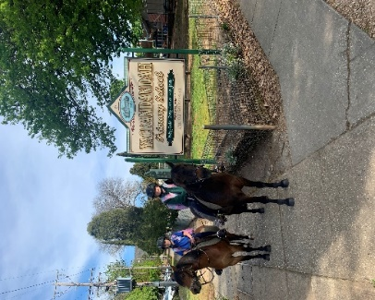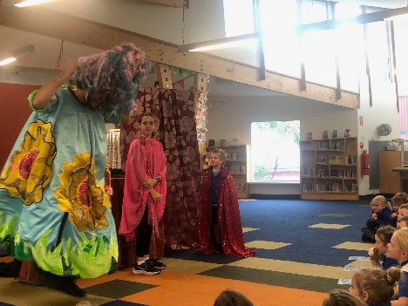
Book Day 2019 Ride to School Day Pass the Poetry Incursion

Snow Skiing – In Term Three each year the Year 5 & 6 students participate in a snow skiing program. This involves three day trips to Falls Creek. Students are offered a choice between cross country skiing or downhill skiing. We aim to keep costs to a minimum.

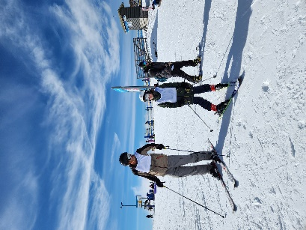
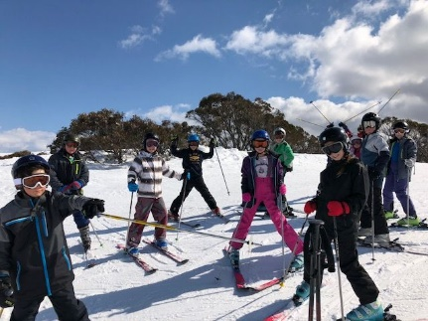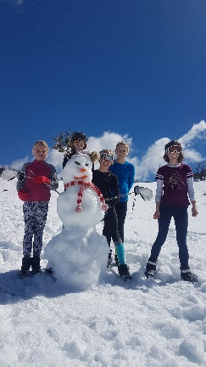
General School Information

ABSENCES:
The DET has initiated a student attendance policy that demands that schools record reasons for absence of students. As such the office should be informed by way of a written note, email or a phone call to the school office, of the reasons for a student's absence.
If a student needs to attend a dentist, doctor or other specialist appointment during school hours the school must be notified. When students leave the school during school hours they need to be signed out at the office by their parent or guardian and signed back in when they return.
Parents can enter an absence and sign students in and out on compass.
ACCIDENT OR ILLNESS AT SCHOOL:
Should your child become ill or have an accident whilst at school, staff will treat the injured or ill child with utmost concern. A high number of staff hold a Workplace Level 2 First Aid Certificate. If necessary, an ambulance will be called. Sick Bay entries are entered onto compass and parents will receive an email notifying them if their child goes to Sick Bay.

Parents are encouraged to be in the Ambulance Fund to avoid undue expenses.
If we feel treatment is needed or that the child should be home, then parents will be contacted immediately. If the parent is unavailable, we will then contact the emergency name given on the child’s enrolment form. If your child receives first aid at school a note will be sent home detailing the treatment given (e.g. ice pack).
Parents will receive a phone call for any incidents involving head injuries.

ADMISSIONS/ENROLMENT FOUNDATION:
If your child turns 5 years on or before the 30th of April, he or she is eligible to be enrolled at a Victorian primary school at the commencement of that school year. Children turning five after the 30th of April must wait until the following year before commencing school.

If you find that you are moving away from Yackandandah, your child will be accepted into the primary school of your choice. Please inform the school if you intend to leave and a transfer note will be issued to the new school.

IT IS IMPORTANT THAT INFORMATION ON ENROLMENT FORMS BE KEPT UP TO DATE.

ADDRESSES:
It is important that the school records are accurate and current. Please advise the office promptly of any change of address or telephone number, and changes to back-up emergency contact numbers.

STUDENT FAMILY OCCUPATION & EDUCATION
Part of our school funding is based on the student’s parent occupation. It is a Commonwealth Government requirement that this information is collected by the schools.

ENROLMENT IMMUNISATION CERTIFICATE:
By law, all parents must provide an Immunisation History Statement when enrolling your child for the first time or when going to a new primary school. This is a statement from the Australian Immunisation Register (AIR) that shows what vaccines your child has received.
The quickest way to get your child’s statement is through MyGOV or by visiting a Medicare Service Centre. Alternatively, you can call AIR on 1800 653 809 and request that a statement is sent to you.

BICYCLES:
If your child intends to ride a bicycle to school, please note the following points.
- Ensure that the child receives careful instruction in road rules including correct hand signals.
- Carry out regular checks on the bicycles for efficiency of tyres, brakes, bell, etc.
- Children must wheel the bike through the side entrance on Wellsford Street to the bike racks situated beneath the Year 5/6 Learning Centre.
- Safety helmets are to be worn.
- Children 10 years and under are not considered capable of constantly following road rules or making accurate judgement of distance and speed. Students under 10 must be accompanied by an adult.

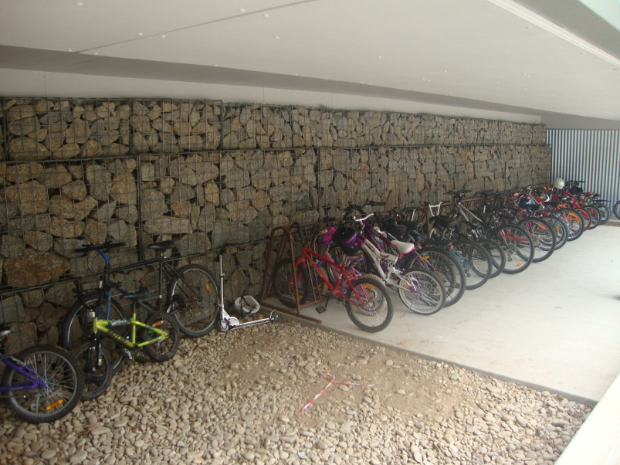

BOOK CLUB
Students are invited to purchase books through Scholastic Book Club twice a term. Order forms are sent home and books can be purchased online through Scholastic.

BUS TRAVELLERS:
The school operates a school bus run through Barty’s Buses. To find out if you qualify for bus travel please call into the office. Students travelling on the bus must remain seated at all times. Training in road safety at home and school will assist in the safe transport of the children. Bus Captains will be appointed at the beginning of each year. The BUS ZONE is intended for bus use only and parents are requested to please observe these signs. N.B. Any child who is not a regular bus traveller MUST obtain permission via a note to the principal before travelling on the bus

PRIMARY SCHOOL NURSING PROGRAM
The Primary School Nursing Program offers all Victorian children a health assessment in their first year at school.
School nurses deliver the program. It gives parents/guardians, teachers and nurses an opportunity to work together for the well-being and educational progress of children. In order to carry out a health assessment, the nurses need to know information that only parents or guardians have about their child. Prior to the school nurse’s visit, parents will receive a School Entrant Health Questionnaire which will assist them to provide this information. Parents are encouraged to consult the school nurse at this time and discuss any concerns they may have. All information is confidential. The health assessment is not intended to replace your normal source of health care. School nurses are also available to see students from other year levels where there are concerns.

COMMUNICATION
Class teachers send regular emails to all families to keep everyone informed about classroom activities, excursions and general reminders. Please ensure the school office has an up to date email address for your family.

CONTACT WITH SCHOOL:
Should the need arise please feel free to contact the school by phone on (02) 6027 1431 at any time. Our Office Manager Sandra McKibbin and Kerryn Wright, will relay such messages to teachers or your child at recess and lunch times.
The principal will usually be available to speak with parents each day. If parents wish to meet with the principal or class teacher, they should ring and make an appointment through the school front office.
Contact can also be made via email.

CONVEYANCE ALLOWANCE
Any families who transport children more than 4.8 kilometres from their place of residence to school or the nearest bus stop may be eligible for conveyance allowance. Please see the office for details.

FOOTWEAR:
Thongs and ‘Crocs’ are unsuitable and unsafe for school wear. Gumboots may be worn on very wet days. Runners should be worn for the Physical Education sessions.

FUNDRAISING:
As monies paid to the school by way of government grants are not sufficient to meet the school’s needs, it is necessary to hold fundraising activities throughout the year. Our main supplementary sources of income are derived from parent contributions and school council activities. Your support in these activities is encouraged and welcomed.
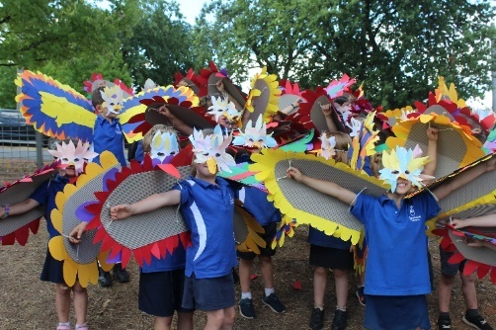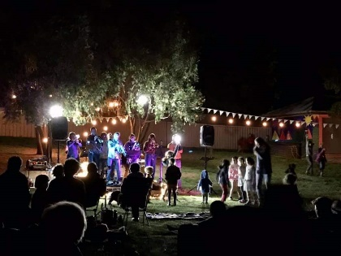
Folk Festival Community Picnic
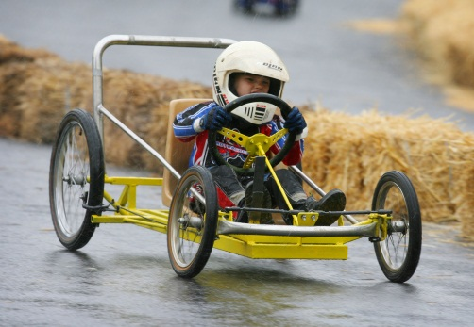
HOT LUNCH:
Hot Lunches are provided by volunteers each week on a Friday, coordinated by the hot lunch supervisor. Lunches include a variety of meals. We welcome and encourage parent assistance and a request for help will be sent out each term. Hot lunches are ordered in advance for the term. Orders forms are sent out near the end of the term for the next term. We aim for hot lunches to be healthy and nutritious in line with our Healthy Eating & Oral Health policy.
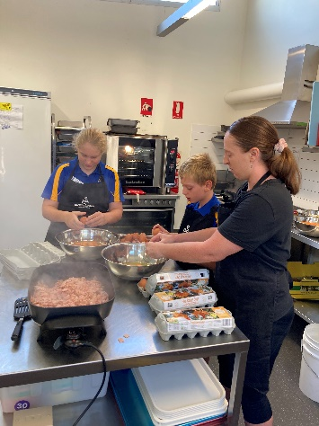
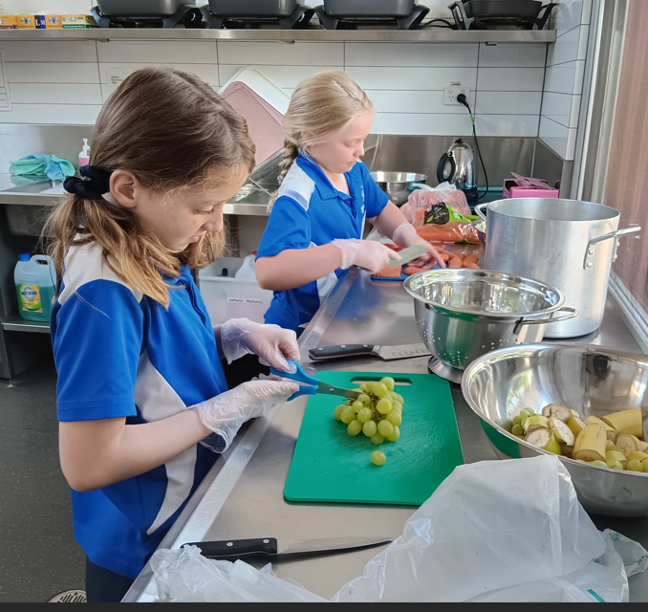

HEALTH SUPPORT SERVICES
Families are encouraged to discuss with the class teacher and principal specific health and learning supports that children may require at school.

HOME LEARNING:
Our home learning emphasis is on home reading throughout the school. Home learning expectations develop with each year level.

Teachers are free to use home learning as a means of assisting a child’s education outside the school setting. Generally, home learning is an extension of the classroom program giving parents the opportunity to share activities with their children. All students are expected to complete home reading each day.

GROUPING OF STUDENTS
The class groupings are primarily determined by the overall school enrolment and staffing allocation granted through the School Global Budget. Each year the school structure is determined through consultation with staff and school council. Students are allocated to class groupings considering friendship groups, siblings and in consultation with the class teacher from the previous year. Student groupings for the next school year take place in Term 4.

INFORMATION NIGHTS:
Early each year, each class has an information night for parents/guardians. Teachers will outline the organisation and program for the year. There is a mutual exchange of information between teachers and parents.

INTERVIEWS WITH TEACHERS:
The school provides opportunity for two parent / teacher interviews during the year and two written reports are issued in June & December. However, we recognise and encourage liaison and co-operation between parents and teachers for the benefit of each student's progress, and for this reason we welcome opportunities to talk with the parents at any time. In order to avoid unnecessary interruptions to classes, it would be appreciated if parents could make an appointment if the need for an extra interview arises.

LIBRARY:
The school has a very well equipped and maintained library which all students are encouraged to use regularly. Parents are asked are asked to provide a library bag (approximately 30cm x 30cm) to ensure that books borrowed are properly looked after. All classes participate in a library session each week. Each class also has the opportunity for visits to the Yackandandah Library located across the road from the school.
LOST PROPERTY:
All articles of clothing and belongings such as lunch boxes, flasks, schoolbags, books, pencils etc. must be clearly and permanently marked with the owner’s name. Please check on this from time to time. Make sure that all articles of clothing worn to school are brought home again each day. If not, check what has happened to them and/or visit the school to check our Lost Property cupboard which is located outside the principal’s office.

MEDICATION/FIRST AID:
Teachers are not expected to administer medication to children. Medication needed by children must be authorised by their parents. Information on medication must be in writing and include child’s name, dosage required and time to be taken. All medicines to be dispensed are kept in the office. The principal (or a delegated member of staff) may supervise such administration. All teachers may give first aid treatment for minor injuries at their discretion. At school we have teachers with First Aid Certificates (Workplace Level 2) and we follow the School First Aid policy and Department guidelines.
Parents will receive a sickbay notification via Compass for any child who receives First Aid. For all head injuries, including minor injuries, parents will be informed via a phone call.

NEWSLETTER/NOTICES
Each Friday the school newsletter is published on the school website. Families will receive an email notifying them when it is available. This includes news, notes and reports. Important dates are on the Event Calendar which appears below the newsletter. The newsletter is our major avenue of communication. If you would like to contribute to the newsletter, all items need to be forwarded to the office by 3.30pm on the Thursday before.

PHOTOGRAPHS
School group and individual photographs are taken annually. Information regarding these is included in the newsletter.

PERSONAL GOODS BROUGHT TO SCHOOL AT OWNER’S RISK
Personal property is often brought to school by students, staff and visitors. This can include mobile phones, calculators, toys, sporting equipment and cars parked on school premises.
Please note the Department of Education and Training does not hold insurance for personal property brought to schools and it will generally not pay for any loss or damage to such property.

PARENT INVOLVEMENT
We encourage parent participation in all aspects of school life. When parents express confidence in the school and are involved in some way, their children are likely to be happier and perform better in the classroom. There are many ways in which parents can be involved:
- Classroom – story writing, reading, typing, computer, library, etc. Please just have a chat to the classroom teacher.
- Working Bees
- School Council/School Council Sub Committees – monthly meetings in the staff room (refer to the newsletter for dates).
- Excursions/camps/sports days.
- Hot Lunches
- Gardening with students

WORKING WITH CHILDREN CHECKS
Parents attending overnight school camps and excursions must have a completed a Working with Children Check. For details contact the school office. WWCC are free and we encourage all parents and volunteers to get one.

STUDENT LEADERSHIP
There are a number of ways for our students to become leaders. This includes being a part of Junior School Council, becoming a School Captain, serving as a House Captain or taking on other responsibilities. We believe that all students, particularly as they become more senior members of the school have a natural leadership role in modelling the school values and assisting others to do the same.

JUNIOR SCHOOL COUNCIL:
At the beginning of the year a boy and girl (in Years 3-6) are elected by each class to represent the class on the Junior School Council. Regular meetings are conducted to give the students an opportunity to have a say in what is happening in their school. The Junior School Council organises special days and activities including fundraising for charities and local organisations.
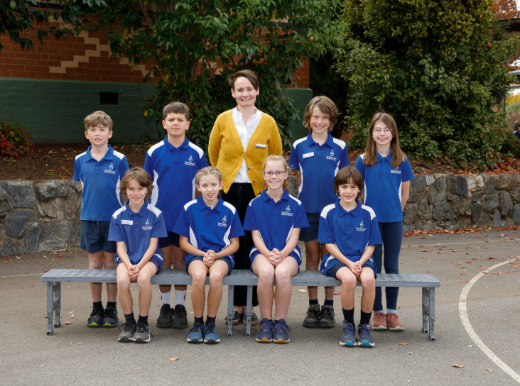

2024 Junior School Councillors.
SCHOOL CAPTAINS:
Four students from Year Six are elected as School Captains at the start of each year. These students represent the school at various community events such as laying the wreath at the Anzac Day Ceremony.

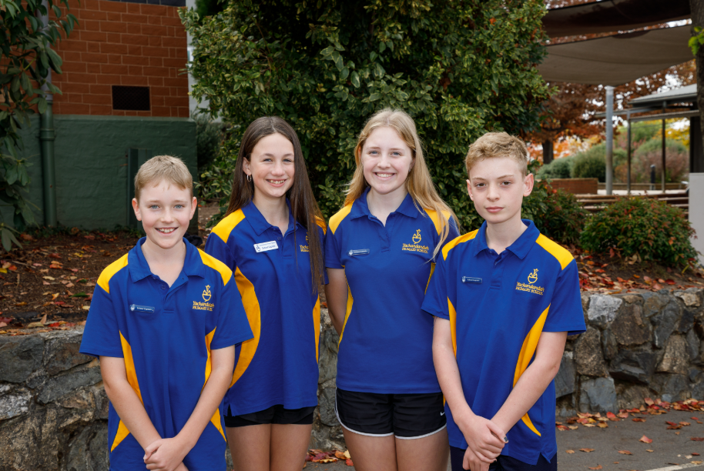

2024 School Captains

HOUSE CAPTAINS:
Yackandandah Primary School has four ‘Houses” – Hammond (blue), Wellsford (red), Kars (green) and Windham (yellow). Students are placed in a house on enrolment. Siblings are in the same house. Students are split into their houses on sporting days and other special events.

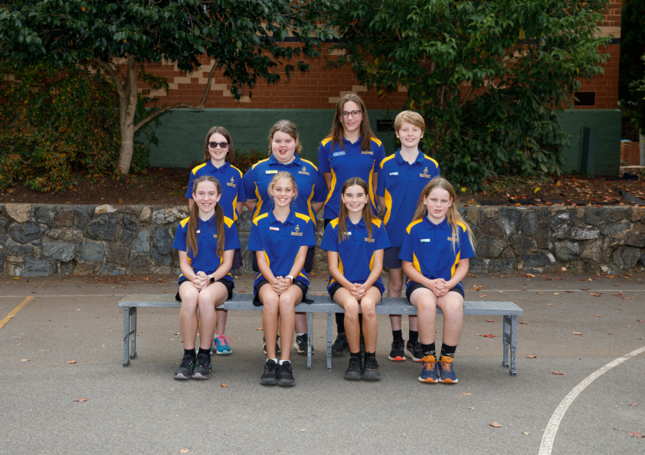

2024 House Captains
FOUNDATIONS
At the beginning of the year our Foundation students tend to take some time adjusting to a full week of school. In 2026 Foundations will not attend school on Wednesdays during February.
Each foundation student is allocated a Year Six buddy. The role of the buddy is to help each Foundation student settle into school routine. At the beginning of the year the Foundation students read with their buddy, eat, play and have lunch together and generally spend time together getting to know one another. Over the years our buddy program has developed into a highlight of our Foundation Transition Program. Foundation students receive a school hat on their first day.

All Foundation students will be given a hat on their first day of school.
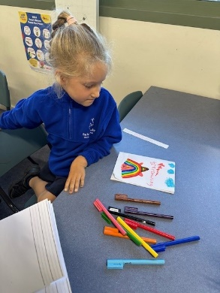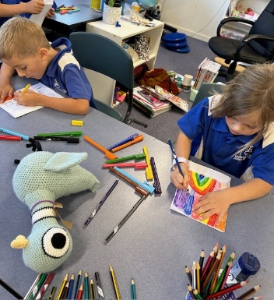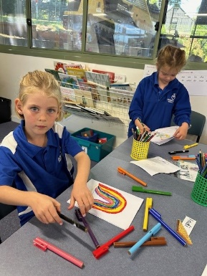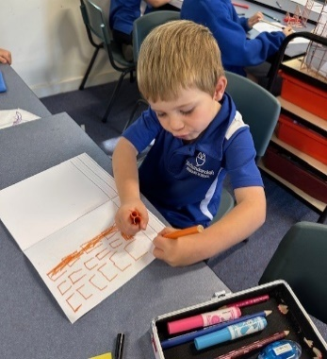

SCHOOL POLICIES:
The school is developing or reviewing policy statements constantly. From time to time they will be updated by School Council. We suggest all parents become familiar with our school’s policy statements. These are all available on the school’s website – www.yackaps.vic.edu.au. Please contact the principal if you require further information in regard to any of these.

WEB SITE: The school’s website is located at www.yackaps@vic.edu.au

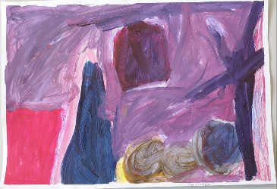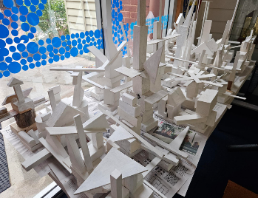

SCHOOL PAYMENTS:
The preferred payment method of family accounts is via the internet into the school bank account. Payment can also be made at the school office or by sending payment with your child.
When sending cash to school we ask that you send funds in a sealed envelope. Please place the following details on the front of the envelope:
- name of the students for which a payment is being made
- the amount of each individual payment
- what the payment is for
- the student’s class e.g. 1/2H
These envelopes will be collected by teachers each morning and sent to the office for processing.

Voluntary school contribution payments:
The School Council Finance Committee makes recommendations as to the amount of money that is needed to provide our students with the necessary education facilities and resources. Once this figure is determined, the School Council sets the contribution structure which is payable by parents.

In 2025 the voluntary contributions per child included:

Essential Costs:
- The Essential costs vary for each Year Level depending on classroom requirements. In 2024 the Essential Learning items included a stationary pack, art consumables, online learning subscriptions and the school swimming program. The Year 5 contribution will also have a netbook payment of $200 added to it.

Optional Costs:
- Skiing – Year 5/6
- Camps – Years 3/4/5/6
- School photos

Other Voluntary Contributions
Parents are invited to make an additional voluntary contribution to the school. School Council suggests a contribution in the range of $100 - $150 per child.

There are also excursions and other activities which are paid during the year. Payment is required before the event. Statements will be sent home to families who omitted to pay.

THE CAMPS, SPORTS AND EXCURSIONS FUND (CSEF)
The CSEF is provided by the Victorian Government to ensure that no students will miss out on the opportunity to participate in educational and fun activities. If you hold a valid means-tested concession card you may be eligible for CSEF. The allowance is paid to the school to use towards expenses relating to camps, excursions or sporting activities for the benefit of your child. More information is available from the school office.

USE OF SCHOOL GROUNDS:
Many students use the school grounds after school hours or on weekends. We are responsible for your child during school hours - up to and including dismissal. However, the school is not responsible for your child after these times. Parents should ensure that children using the school grounds after school do so in a safe manner with the appropriate supervision and respect for school property.

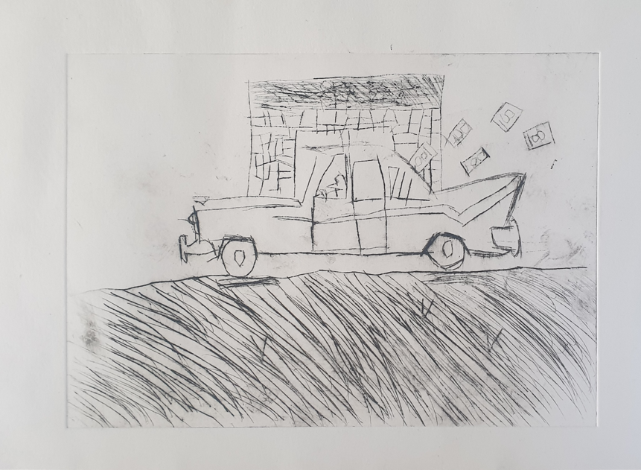

WET WEATHER
During periods of wet or inclement weather, children are supervised by teachers in classrooms.

YARD DUTY SUPERVISION
During recess/lunchtime and before/after school the school grounds are supervised by teachers on a roster basis. Students are expected to follow playground rules. Yard duty supervision commences at 8.40am and concludes at 3.40pm.

SPORT & PHYSICAL EDUCATION:
The school organises programs in Sport and Physical Education and children are expected to participate in them. Sometimes it involves inter-school activities. The key is healthy participation. If for some reason your child is unable to join in, then please inform the teacher.
Children are requested to wear or carry clothing appropriate to these activities.
Annual events include:
Term 1 – School Swimming sports – Years 3-6
Term 2 – Cross Country – whole school
Term 3 – Athletics – whole school, Snow skiing – Years 5/6, Winter Sports Years 3/4/5/6, school swimming program – whole school
Term 4 –Kanga Cricket - Years 3/4/5/6

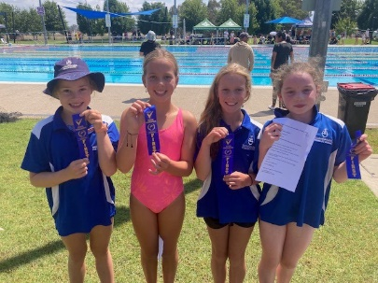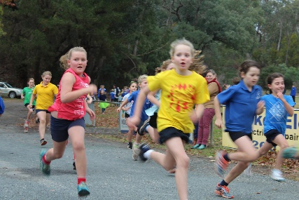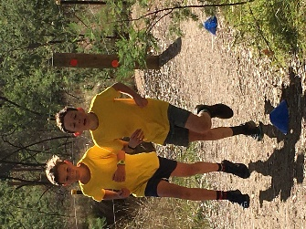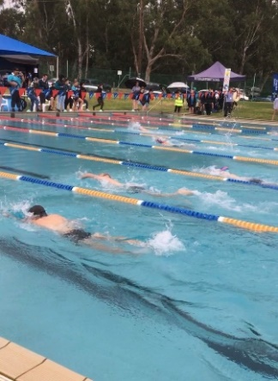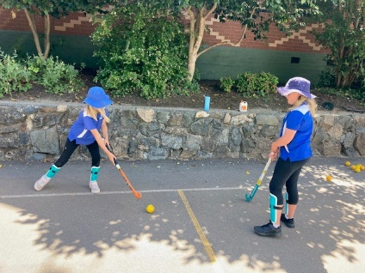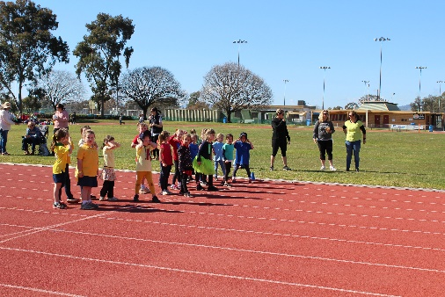

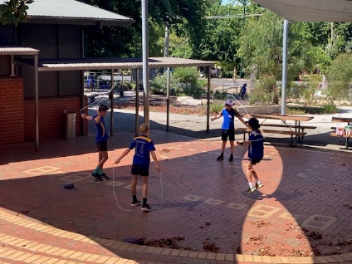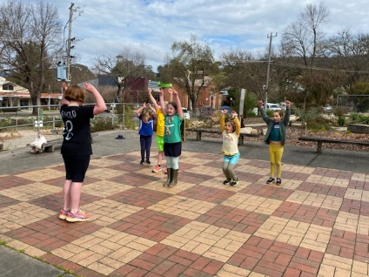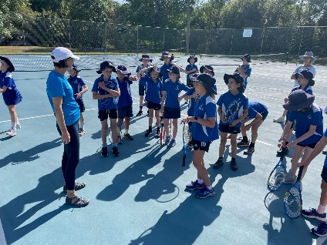

SWIMMING:
We believe that developing water safety and swimming skills as very important. Our intensive program takes place in November for all students at the Wodonga Sports & Leisure Centre. All students are expected to participate and come to school with correct attire.

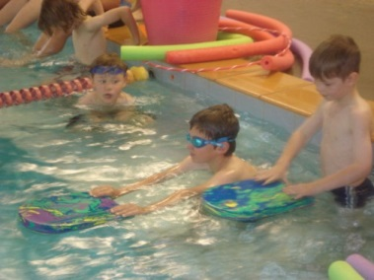
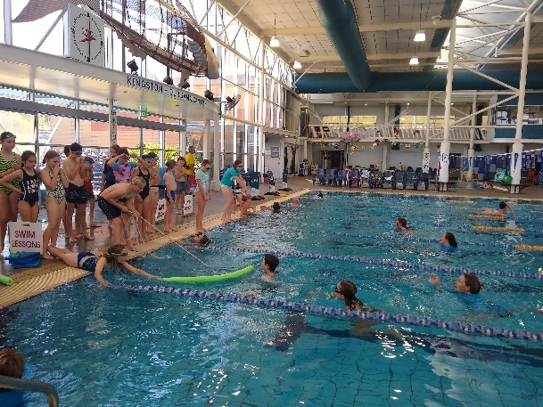

UNIFORMS:
The wearing of the school uniform is not compulsory, but we strongly encourage all students to be dressed in the official school uniform:
Summer: Blue & white checked dress
School polo shirt - royal blue
Unisex shorts - navy
Skort - Navy
School hat – navy

Winter: School polar fleece jumper - royal blue
School polo shirt - royal blue
Skivvy - royal blue
Tracksuit pants – navy

Sports: Unisex shorts and a school polo shirt with
Appropriate sporting shoes [for both girls and boys]
Swimwear - own choice

Hats: Our school is a Sunsmart School with a policy that students wear broad-brimmed hats when the UV rating is above 3.0 when in the playground, on the sporting field or on an outdoor excursion

A NO HAT, NO PLAY POLICY OPERATES!

It is appropriate students wear comfortable, easy to look after clothing which allows them freedom to participate in activities yet provide sufficient protection on hot days.

Shirts, polar fleece jumpers and hats are available to purchase from the school office. Shorts, track pants skivvies and blue and white checked dresses are available at most major clothes retailers.  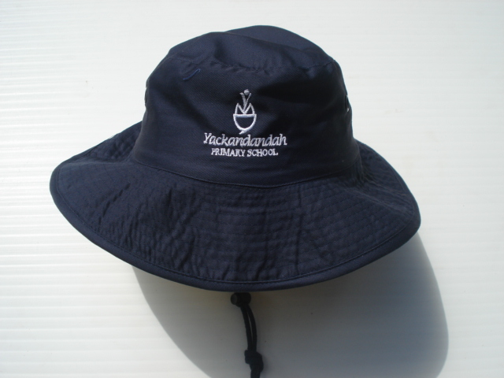 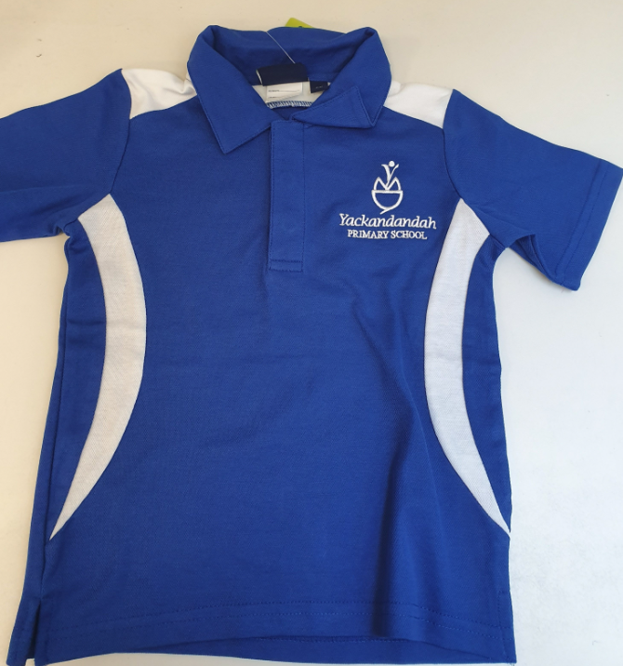

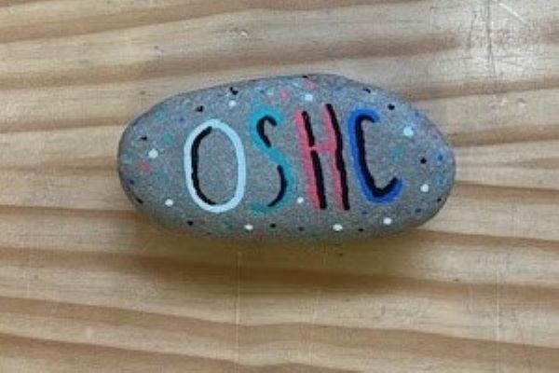

OUT OF SCHOOL HOURS CARE PROGRAM:
Before, after and vacation school care is available at the school. These programs operate at the school daily from 7.00 am to 8.50 am for before school care, 3.30 p.m. - 6.00 pm for after school care and during school holidays (8am to 6pm).
The cost of the program is as follows:
Before School Care: $18 per session
After School Care: $25 per session
Vacation Care/ Pupil Free Days: $60 per day

The initial enrolment form and bookings are created through the OSHC portal.
More detailed information can be found in the OHSC Parent Information Booklet.
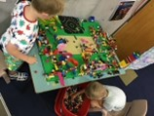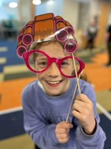
HOW YOU CAN HELP YOUR CHILD WITH LEARNING

Oral Language - Encourage your child to talk about experiences that they have during the day. Show them how to use language for different situations.

Writing – Let your children see you write. Be an interested listener and reader and praise writing done at home and at school. Encourage your child to write shopping lists, letters, stories, diaries and notes.

Reading – Read to your child as often as you can and encourage them to read. Praise all efforts in reading and encourage a love of books. Remember the three P’s - Pause, Prompt, Praise - when listening to your child read.
- Pause – Before responding it is important to wait first, giving the child time to work out the word for themselves.
- Prompt – Encourage the child to look at the pictures, if the word makes sense, allow the child to continue reading. If the word doesn’t make sense encourage the child to have another try.
- Praise – At all times it is important that children are praised and encouraged for their efforts.

Spelling – Encourage and praise all efforts – even if the words are spelt incorrectly. Show children how to learn new words by relating the sight and sounds of letters and words and focusing on letter patterns within parts of words.

Maths – Encourage your child to make use of maths in everyday family activities e.g. weighing, measuring, shopping and cooking.

The Arts – Encourage and value the work and productions in which your child is involved. Provide opportunities for your child to create and perform.

LOTE – Use a globe of the world to talk about world events and cultures.

Science – Develop your child’s curiosity about the natural and the built world by experiencing the environment. Share factual books, make a vegetable garden and conduct some simple kitchen experiments.

Humanities – Participate in community events and visit community institutions such as the museum, historical houses and gold mines. Discuss local history and discuss current issues. Help your child research information.

Technology – Encourage your child to be aware of the role that simple and complex technologies play in their lives. Provide supervised opportunities for your child to access the internet.

Thinking – Provide opportunities for your child to explore and create with a range of objects and materials. Talk about thinking processes and use graphic organisers to assist in family organisation. Get to know the Habits of Mind.

Health & Physical Education – Encourage your child to eat healthy lunches and snacks and make responsible food choices. Send a water bottle to school for your child to keep on their classroom table to ensure they are sufficiently hydrated throughout the day. Also send along at least one piece of fruit for your child to eat during fruit break. Make sure your child has regular exercise and sufficient sleep.

Personal Learning – Help your child make choices, set personal goals, persist with activities, play games fairly and learn the consequences of their actions. Help them get organised with their belongings and time. Help your child take on roles and responsibilities.

Let the school know of any home issues that may affect your child’s learning at school and importantly if you have any concerns or questions please make an appointment with your child’s class teacher or the principal. It is always best to address the issue early rather than leave it to grow into something bigger and more difficult to manage.

YOU CAN HELP AT SCHOOL BY:
- Nominating for School Council. These positions are advertised through newsletters
- Reading all school newsletters and notices
- Attending Parent/Guardian – Teacher meetings
- Assisting with fundraising activities
- Assisting with the reading program
- Assisting with excursion supervision
- Taking an active interest in your child’s work. Read and display work
- Helping at working bees
- Visiting your child’s classroom often and giving moral support to class teachers
- Promoting our School within the Community.
It is very important that you READ WITH YOUR CHILD EVERY DAY

INFECTIOUS DISEASES:
DET regulation requires the parent / guardian to inform the school principal as soon as practicable if their child is infected with any of the diseases listed in the table. The table sets out times of exclusion from school.

Infectious Diseases:
Communicable Diseases – Minimum Exclusion from Schools and Children’s Services Centres’
Chickenpox | Until fully recovered or at least one week after the eruption first appears.
Conjunctivitis (acute infectious) | Until discharge from eyes has ceased.
Diphtheria | Until receipt of a medical certificate of recovery from infection.
Giardiasis (diarrhoea) | Until diarrhoea ceases.
Hepatitis | Until receipt of a medical certificate of recovery from infection, or on subsidence of symptoms.
Hepatitis B | Until recovered from acute attack.
Impetigo (school sores) | Until sores have fully healed. The child may be allowed to return provided that appropriate treatment has commenced and that sores on exposed surfaces such as scalp, face, hands and legs are properly covered with occlusive dressings
Leprosy | Until receipt of a medical certificate of recovery from infection.
Measles | Until at least 5 days from the appearance of rash or until receipt of a medical certificate of recovery from infection.
Meningococcal infection | Until receipt of a medical certificate of recovery from infection.
Mumps | Until fully recovered.
Pediculosis (head lice) | Until appropriate treatment has commenced.
Pertussis (whooping cough) | Until two weeks after the onset of illness and until receipt of a medical certificate of recovery from infection.
Poliomyelitis | Until at least 14 days after onset of illness and until receipt of a medical certificate of recovery from infection.
Ringworm | Until appropriate treatment has commenced.
Rotavirus (diarrhoea) | Until diarrhoea ceases.
Rubella | Until fully recovered or at least 5 days after the onset of rash.
Scabies | Until appropriate treatment has commenced.
Shigella (diarrhoea) | Until diarrhoea ceases.
Streptococcal infection (incl Scarlet Fever) | Until receipt of a medical certificate of recovery from infection.
Trachoma | Until appropriate treatment has commenced.
Tuberculosis | Until receipt of a medical certificate from a health officer or Dept. of Human Services that the child is not infectious.
Typhoid & Paratyphoid | Until receipt of a medical certificate of recovery from infection.

